|  |  |  |
| --- | --- | --- |
| I | A | M |
| G | O | L |
| D | E | N |

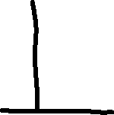

|  |  |  |
| --- | --- | --- |
| I | A | M |
| G | O | L |
| D | E | N |

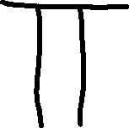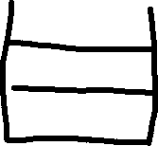

I A M

G O L

D E N

_ _ _ G E _

P O G E R S

B E L O N G

B U D G E T

D A N G E R

C O M I N G

G O L D E N